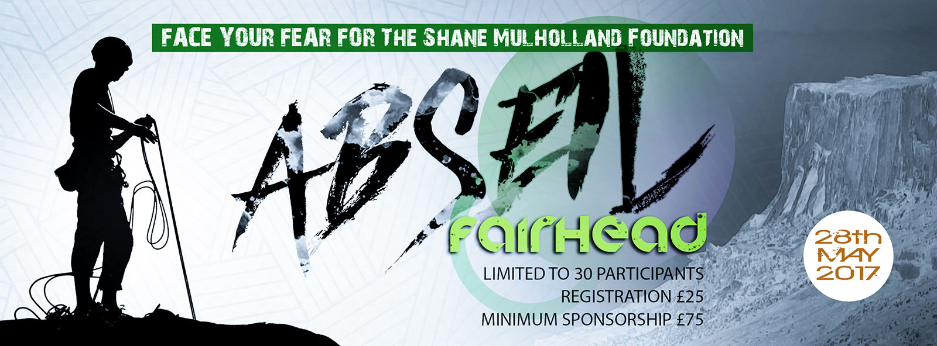
On 28th May 2017, I will be attempting to Abseil from the top of Fairhead, Co.Antrim to raise funds for The Shane Mulholland Foundation.
Your support is much appreciated.

NAME | MESSAGE | DONATION AMOUNT

